Asanda Brain Dumps

1. Validate text:

Q: <input id = “txtValue” type=”text” />

A: D

function validate() {

1 var value = $(“#txtValue”).val();

2 var regex = /^[\d\,\.]*$/;

3 if (!regex.test(value) || value == “”)

4 alert(“please enter valid value”);

5 return;

}

6 return emailPattern.test(userinput);

}

Breaking down this function line by line.

1. is calling the txtValue id from html input probably.
2. regex stands for RegExp or Regular Expression. We’re assigning a RegExp to the variable regex. Everything inside of the / … / is the RegExp.

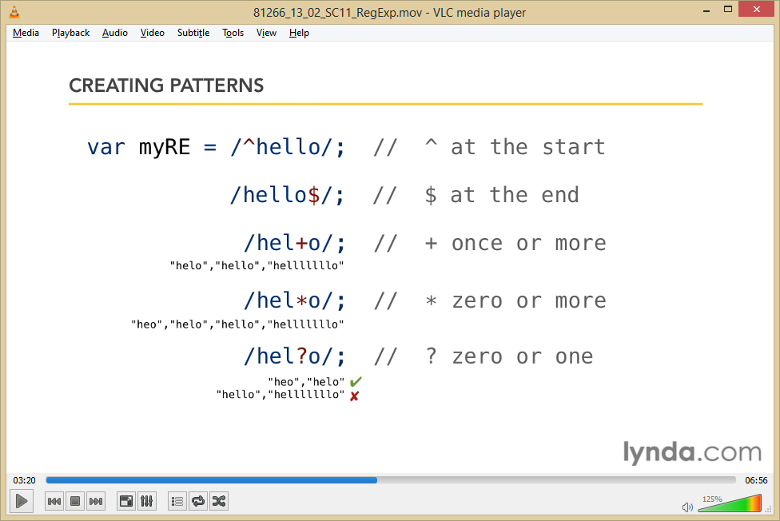

/ - start and end

^ - denotes that what Is after it must come first.

From Chap 13 - Lyna Vids

[^abc] find any character NOT between the brackets

\d – find a digit

\, - find??

\. – find a single character, except newline or line terminator

[…]* - matches any string that contains zero or more occurrences of what is inside […]

[…]*$ - matches any string with […]* at the end of it.

[W3CReference](http://www.w3schools.com/jsref/jsref_obj_regexp.asp)

1. if the value is NOT empty OR if the value is NOT one of the things we’ve assigned as a regular expression (i.e. regex) then
2. alert the user to input a valid value and once this has been activated
3. return to the top of the function to begin validation on the new input from the user. However, if the user inputted a value that passed validation (i.e. a valid value) then proceed to
4. ????

Comparing Options:

A and D are extremely similar.

-They differ at line 1 where A created the variable and pulled the info as a .text(); rather than D’s as a .val();

-They also differ at line 3 where A says if name is equal to empty which doesn’t make sense as name is not a variable that has been defined however in D, it makes sense that value can be equal to empty because that’s the variable we have created.

-Line 6 doesn’t exist for A. And I don’t understand what it’s doing in D.

Questions:

1. Why is it correct for line 1 to have .val instead of .text?
2. What is line 6 doing in D?